**LANDING PROCEDURES**

**TPA -Traffic Pattern Altitude:** 1000’ above Field Elevation

**FLYOVER:** 500’ above TPA

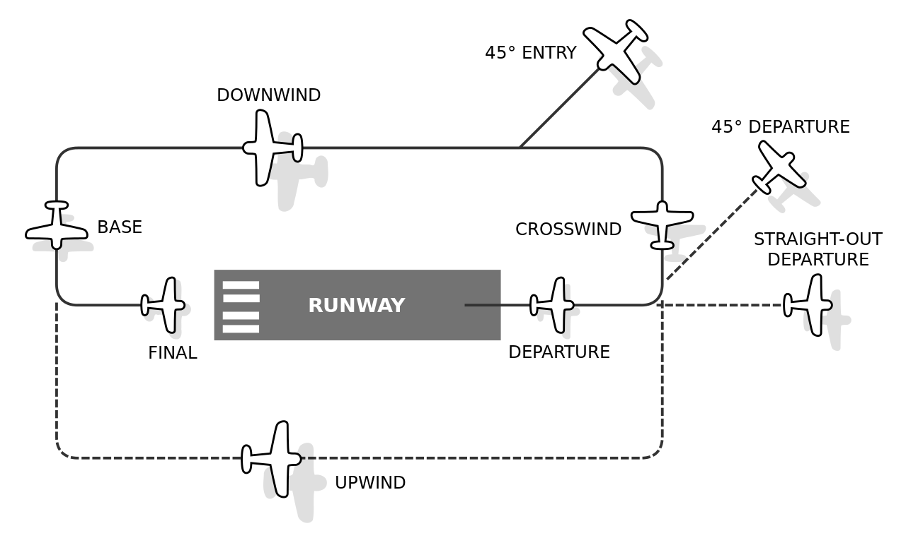

**WIND** – ➔    **TETRAHEDRON**–

**TAKE OFF / LANDING**– ⬅    Land Direction it’s Pointing

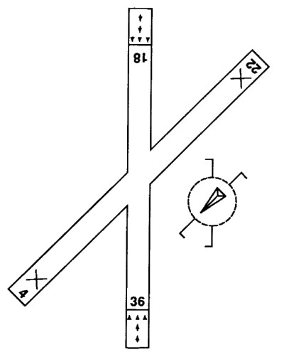

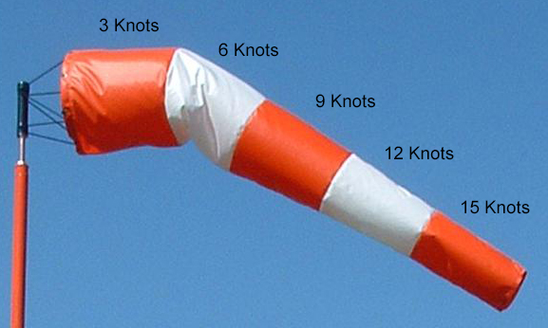

**AIRPORT LIGHTING**

**PCL- Pilot Controlled Lights:** Use Mic (7x Max Intensity)

**Runway Edge:** White

**Taxi Edge:** Blue

**AIRPORT BEACONS**

**LAND AIPORT:** Green, White

**WATER AIPORT:** Yellow,White

**HELIPORT:** Green, Yellow, White

**MILITARY:** Green, White, White

**CLASS D (Daytime):** Green, White = weather not VFR

**APPROACH INDICATORS**

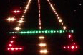

**VASI – Visual Approach Slope Ind:**

Red, Red – Too Low

Red, White – OK

White, White – Too High

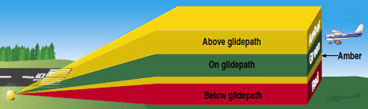

**TRICOLOR VASI:**

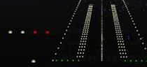

**PAPI –Precision Appr Path Ind:**

4 Red – Too Low

3 Red – Low

2 Red – OK

1 Red – High

0 Red – Too High

**PASI –Pulsating Approach Slope Ind:**

Pulsing Red – Too Low

White – OK

Pulsing White – Too High

**AIRPORT SIGNS**

